Title Here

Author Name1, Author Name2, Author Name3

Affiliation University, School, Department, Institute
Address, City, Postal Code, Country
E-mail

Abstract
This is the template for preparing an extended abstract for ISTFD-2023: the 4th International Symposium on Thermal-Fluid Dynamics, Nanjing, China, July 27-29, 2023.The abstract section should describe the objectives, the methodology and the main conclusions of the paper.
The figure, table, equation should be inserted in the abstract. And the references should be included. The extended abstracts must be formatted strictly according to these instructions.
One Example of Figure
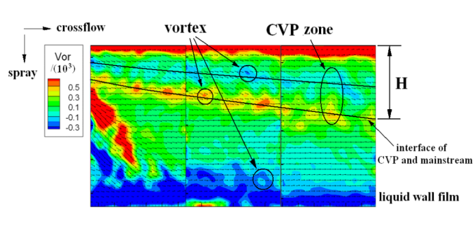
Figure 1: Place here the figure caption.

One Example of Table
Table 1 Specifications of the test section
Case No. | 1 | 2 | 3 | 4
d_{p}(mm) | 5 | 6 | 7 | 8
Length(mm) | 260.48 | 311.80 | 364.67 | 361.33
Width(mm) | 45 | 54 | 63 | 72
Height(mm) | 6.58 | 7.9 | 9.22 | 10.53

Equations
$$\left[M\right]\left\{\overset{¨}{x}\left(t\right)\right\}+\left[C\right]\left\{\overset{˙}{x}\left(t\right)\right\}+\left[K\right]\left\{x\left(t\right)\right\}=f\left(t\right)$$ | (1)
$$M\overset{¨}{x}\left(t\right)+C\overset{˙}{x}\left(t\right)+\text{Kx}\left(t\right)=f\left(t\right)$$ | (2)

Citations
Please list the references following the examples in the end of this template (Wallis 1969; Bagnold 1954; Taitel & Barnea 1993).

References

Bagnold, R. A. Experiments on a gravity-free dispersion of large solid spheres in a Newtonian fluid under shear. Proc. R. Soc. Lond. A, Vol. 225, pp. 49 – 63 (1954)
Taitel, Y. & Barnea, D. A model for slug length distribution in gas-liquid slug flow. Int. J. Multiphase Flow, Vol. 19, pp. 829 – 838 (1993)
Wallis, G. B. One-dimensional two-phase flow. McGraw- Hill, (1969)

